

|  |
| --- |
| ***BS Cyber Security Department AU*** |

|  |  |
| --- | --- |
| **Registration ID** | **233026** |
| **Submitted By** | **Muhammad Sohaib Rafiq** |
| **Submitted To** | **Iram Fatima Hashmi** |
| **Date of Submission** | **12/02/2024** |
| **Lab NO.** | **1** |
| **Subject** | **OS LAB** |

**IP Spoofing using VPN Tool:**

**IP(public) Before VPbook vpn:**

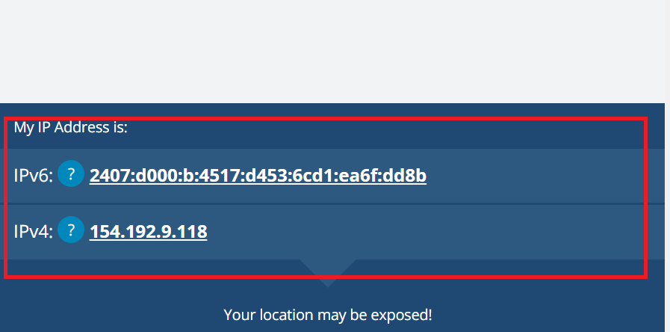

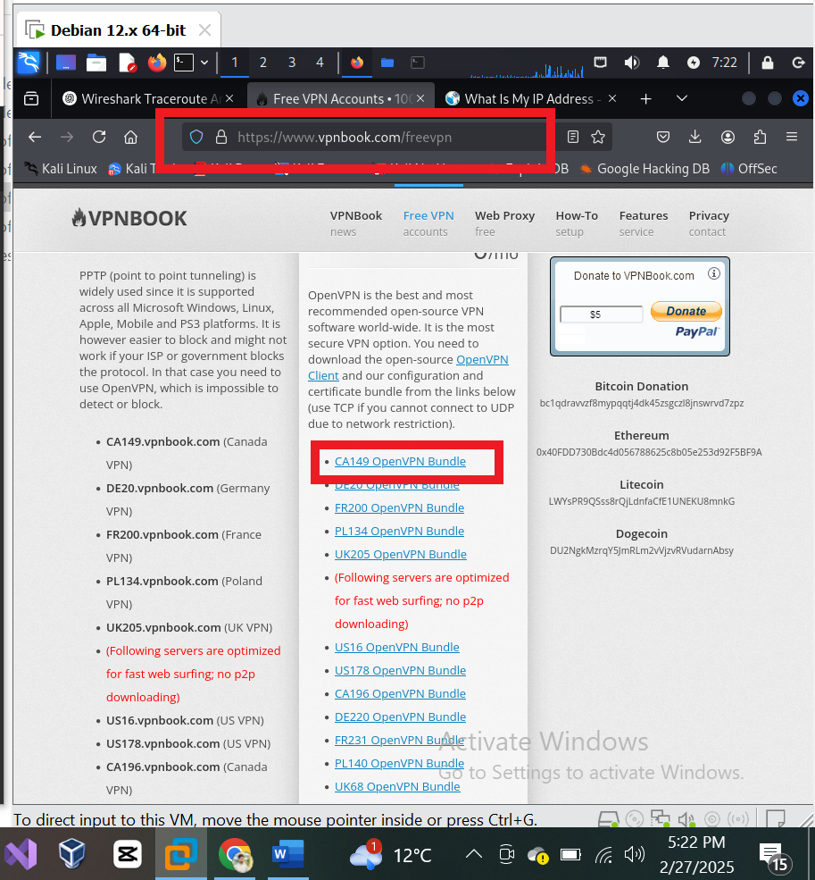

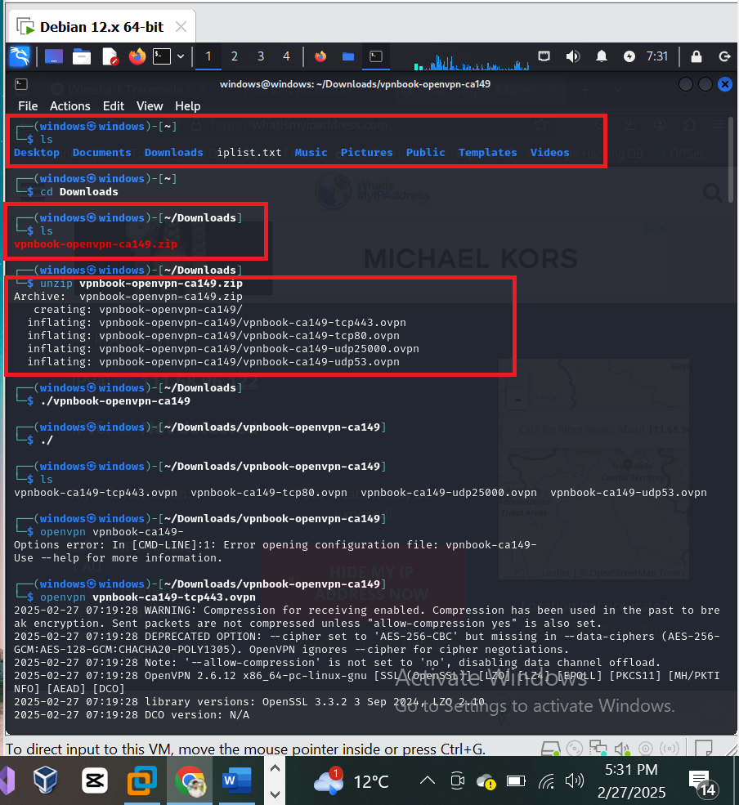

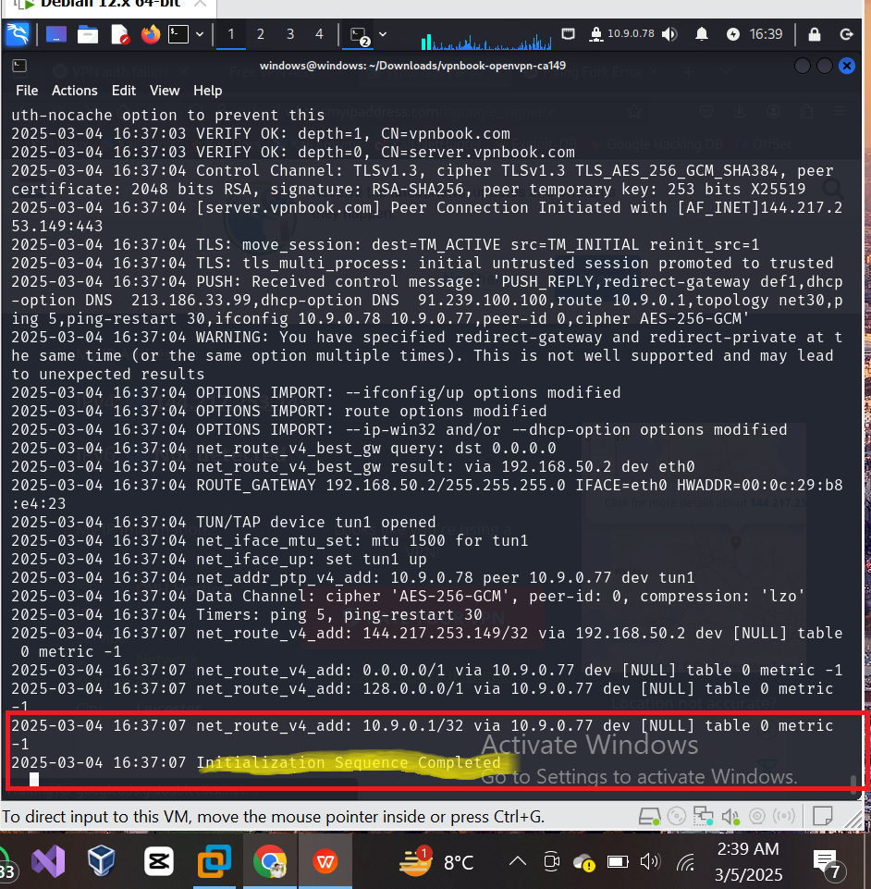\

Output Results:

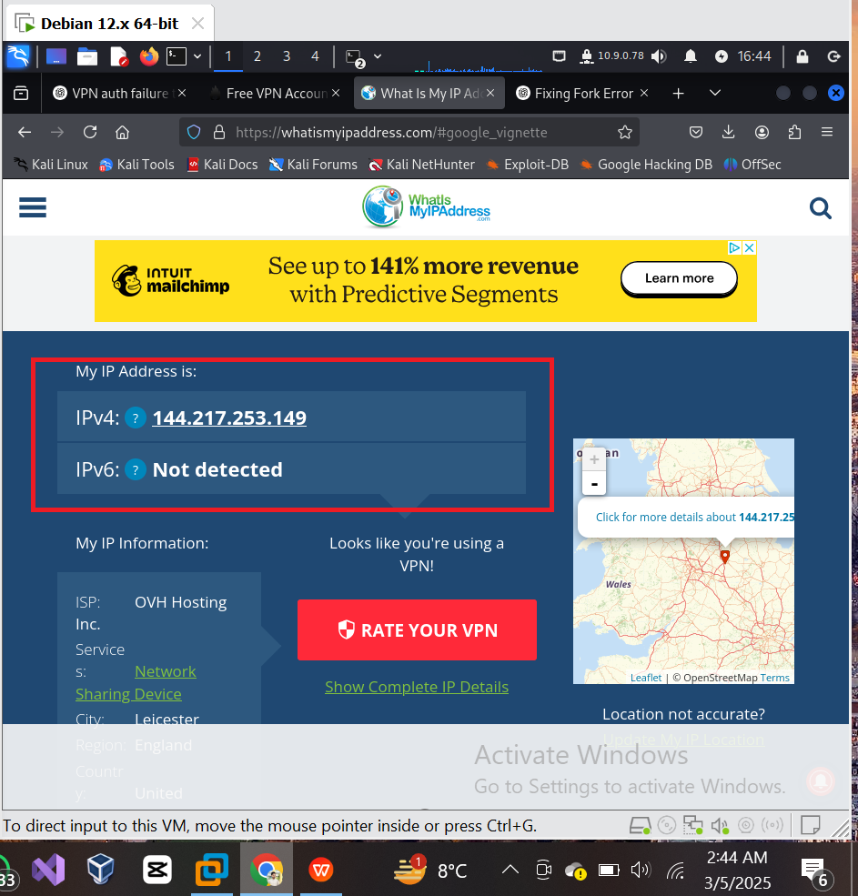

**Using Anonsurf:**

**• Download and clone anonsurf:**

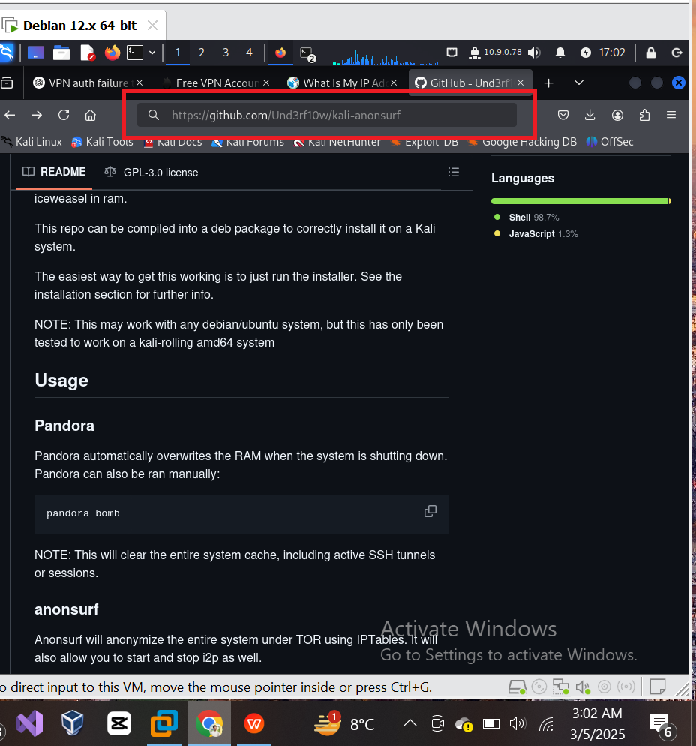

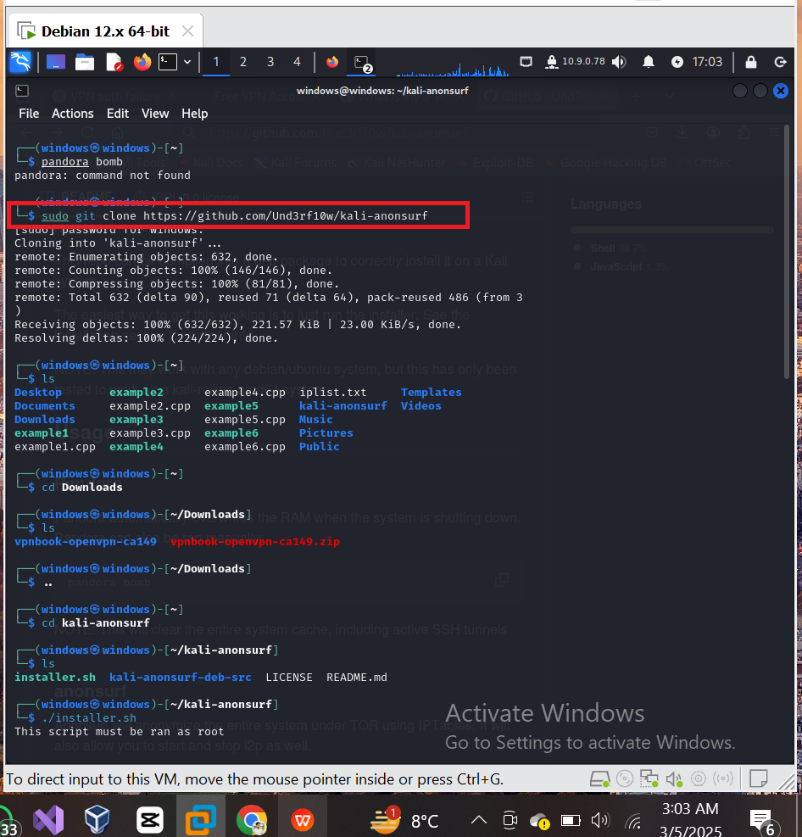

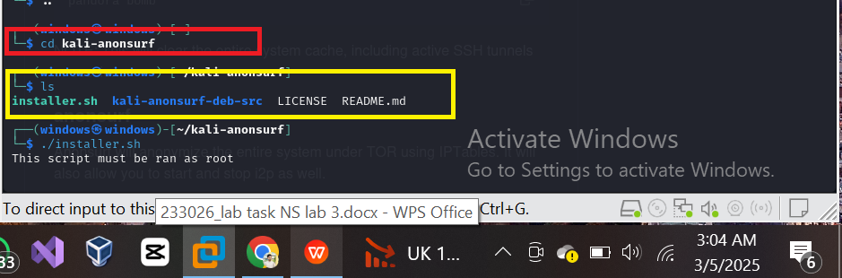

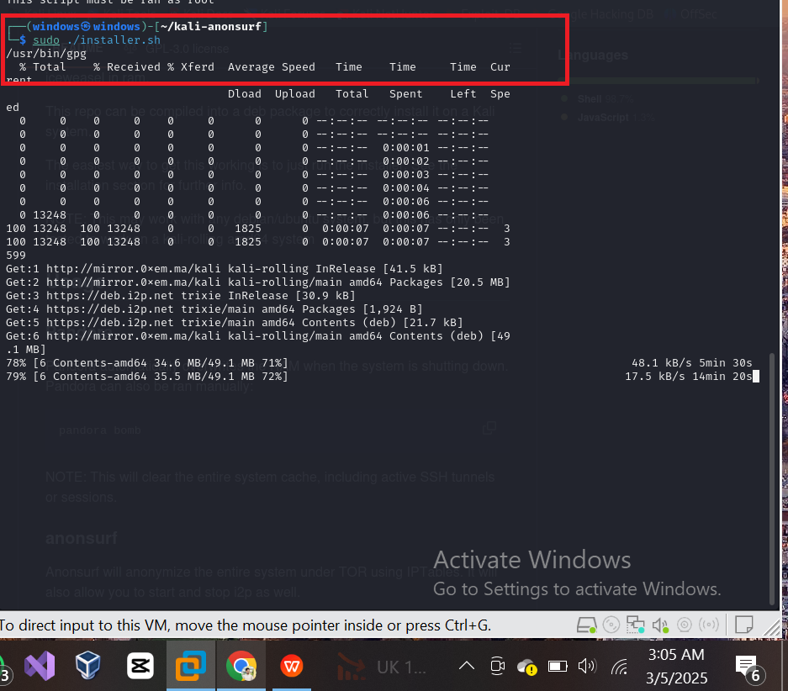

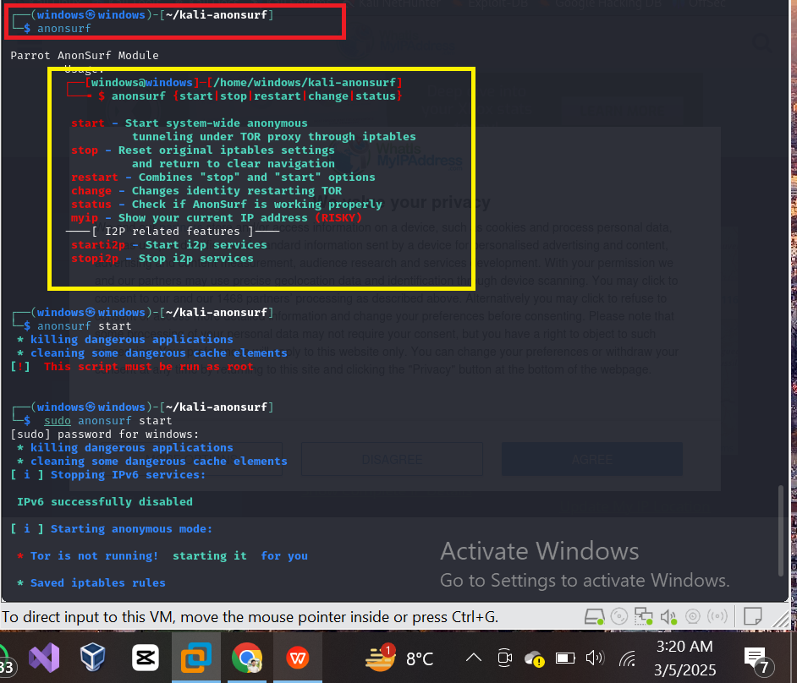

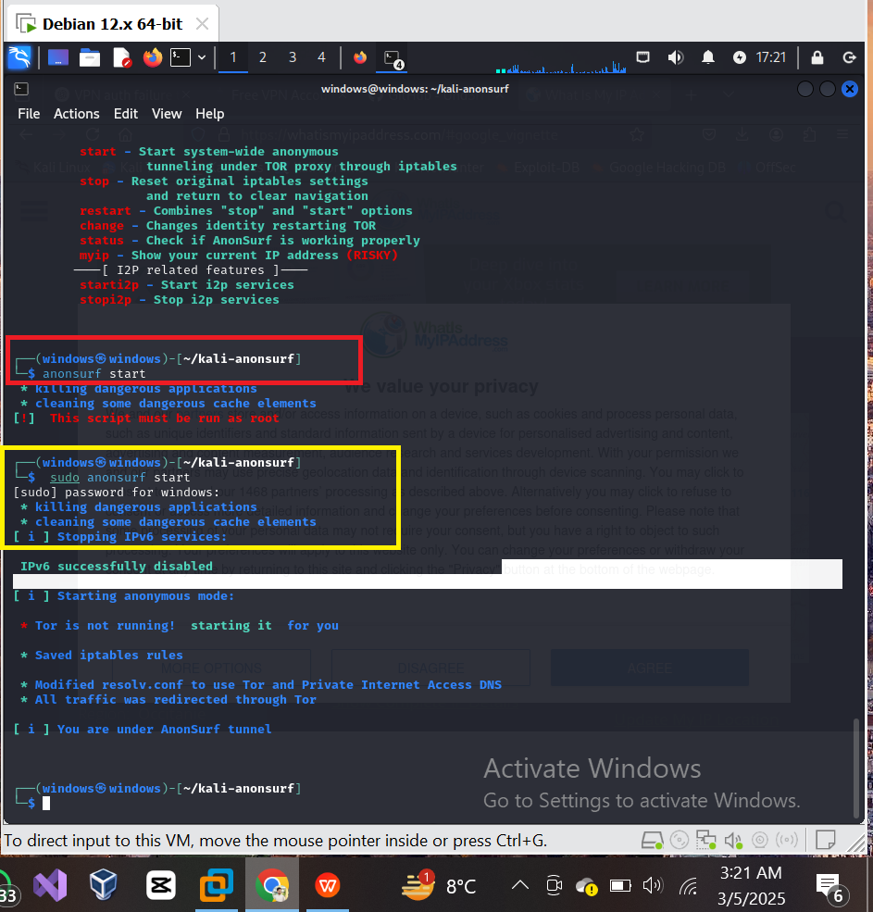

**Output Screenshots:**

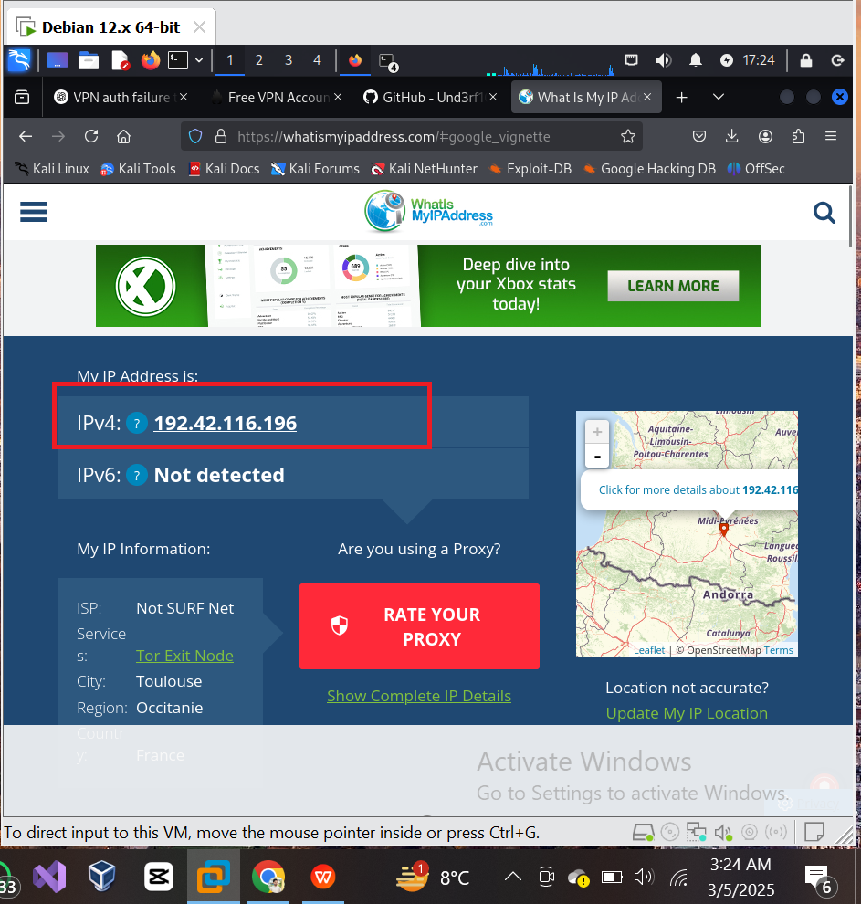

1. **MAC spoofing:**

MAC spoofing is a technique for changing a factory-assigned Media Access

Control (MAC) address of a network interface on a networked device.

**Mac-Address Chaning in windows:**

Mac address before change:

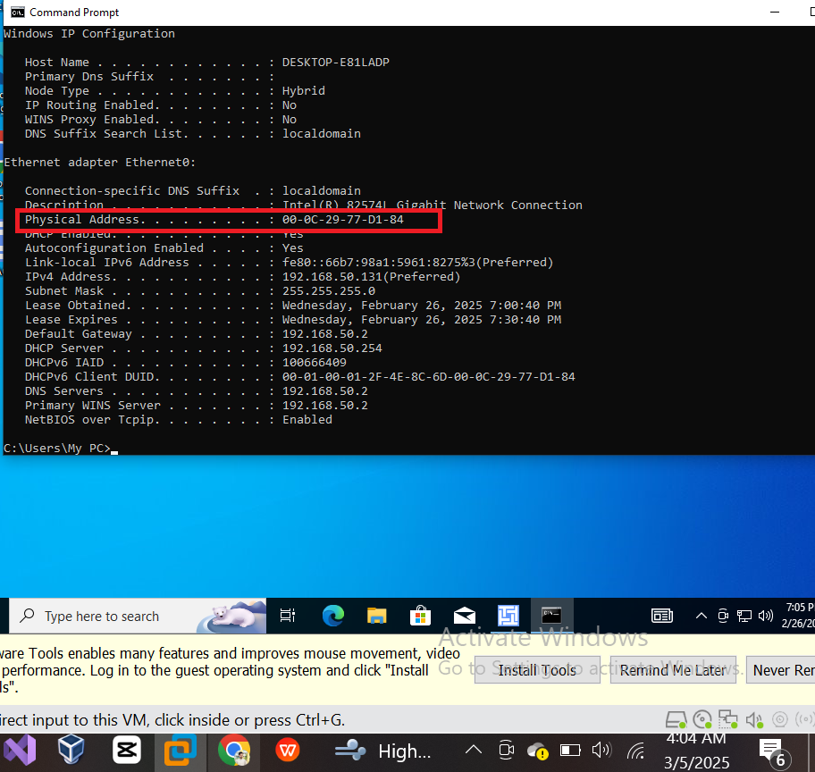

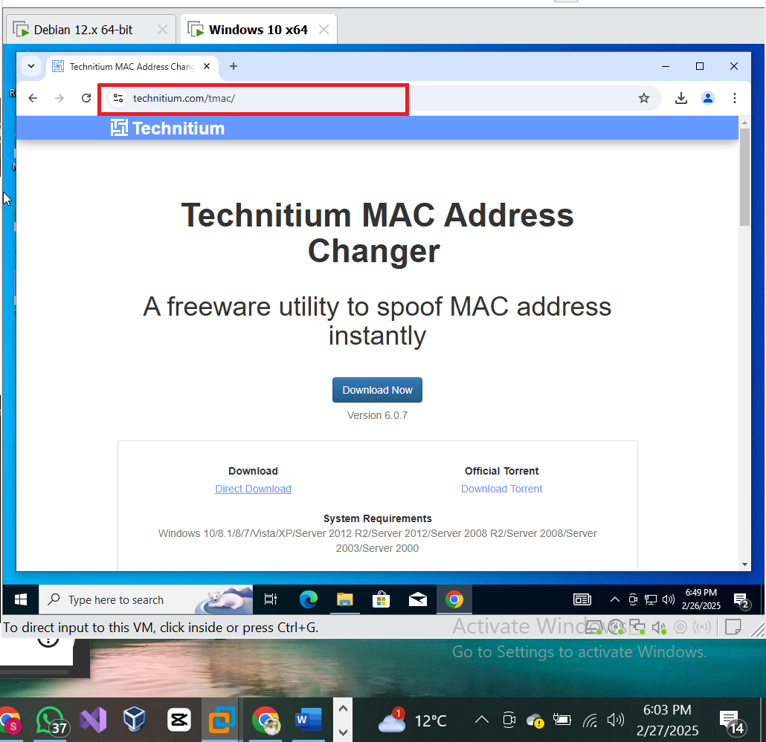

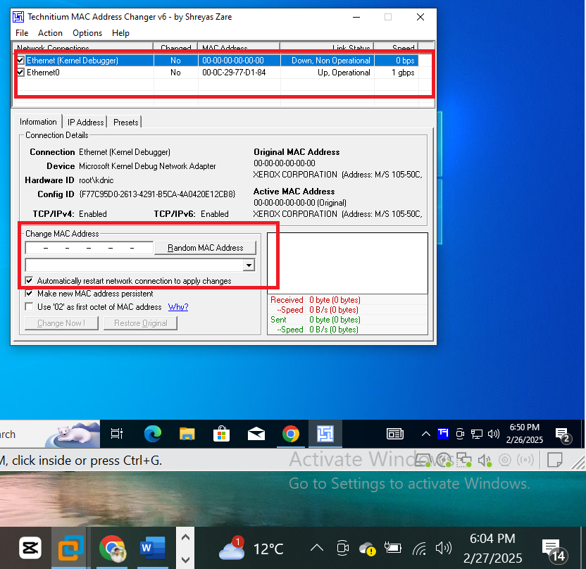

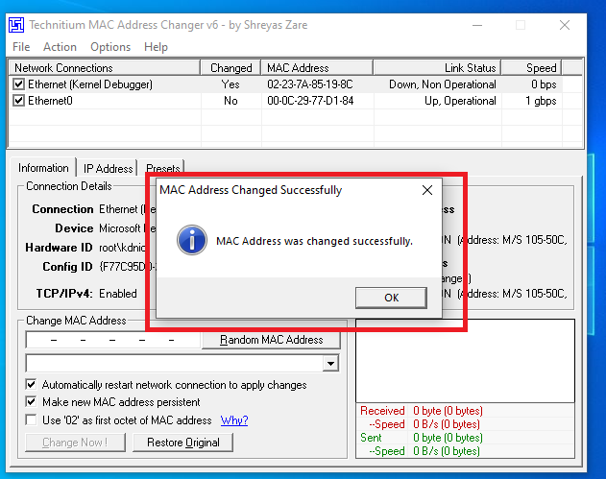

Mac address after change:

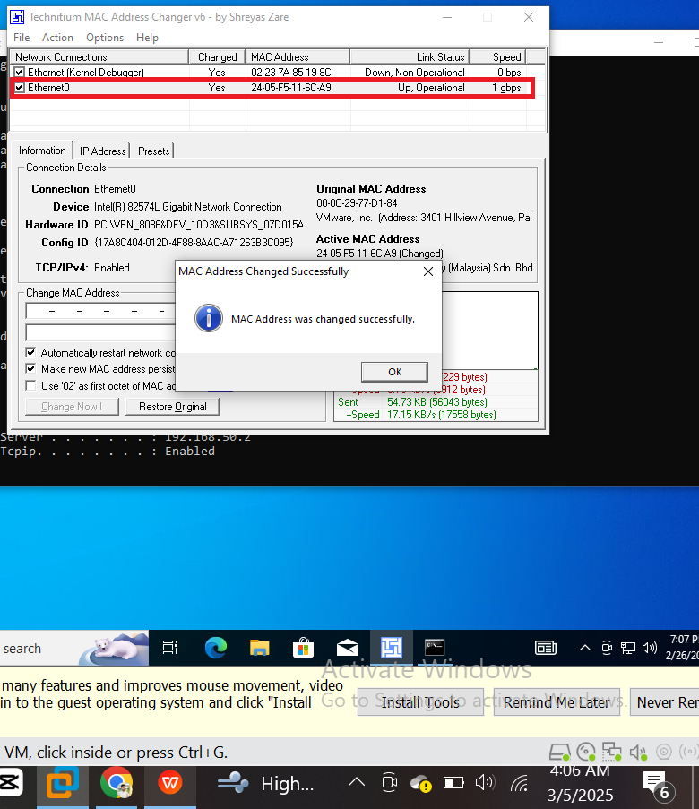

**Mac address Changing in Kali Linux:**

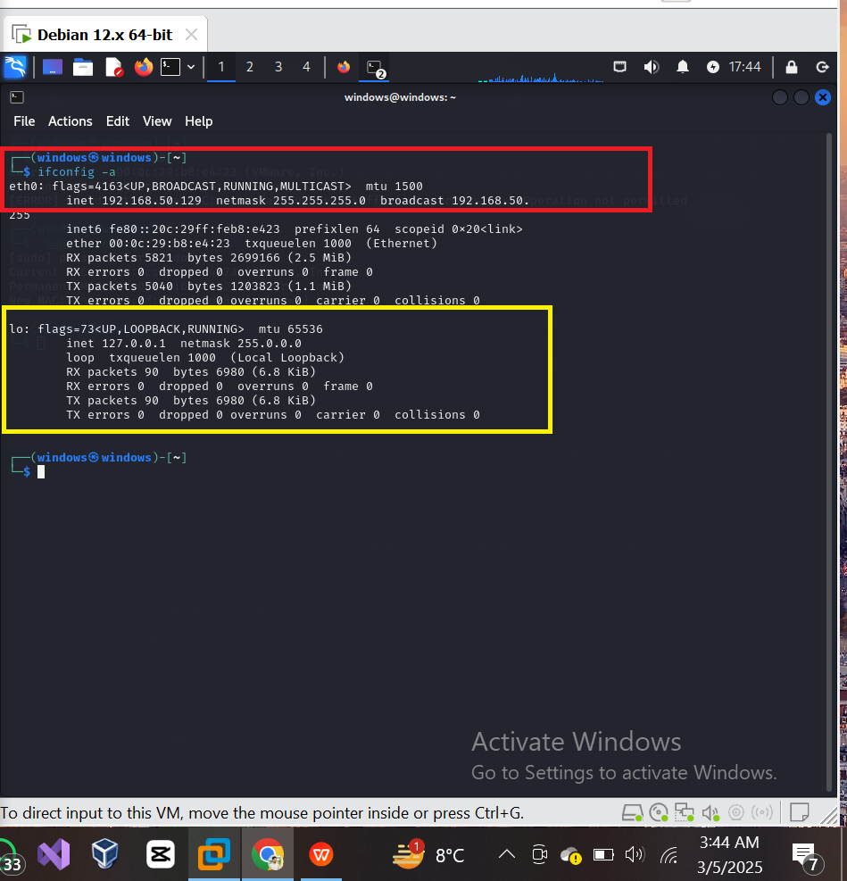

Output Results:

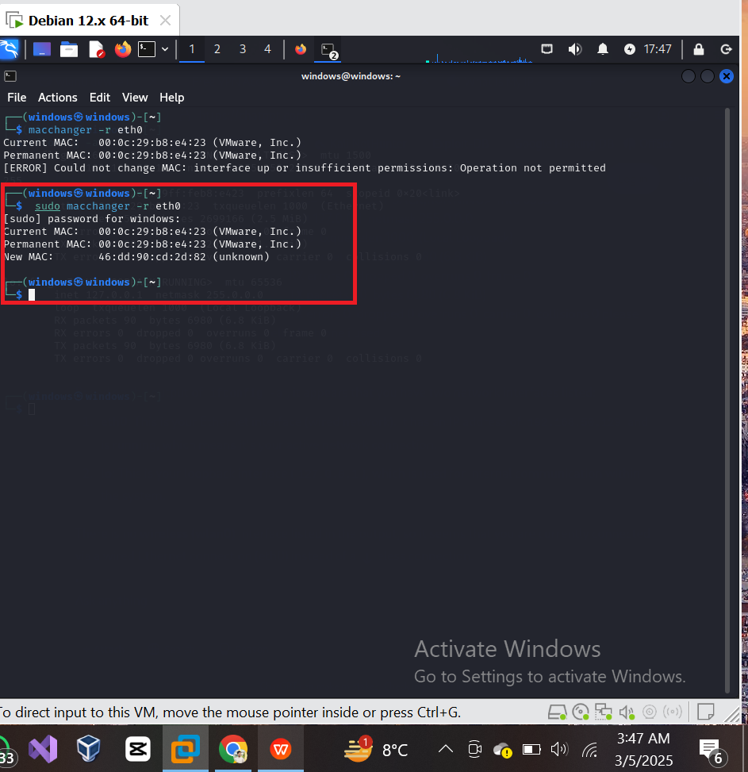

EMAIL SPOOFING

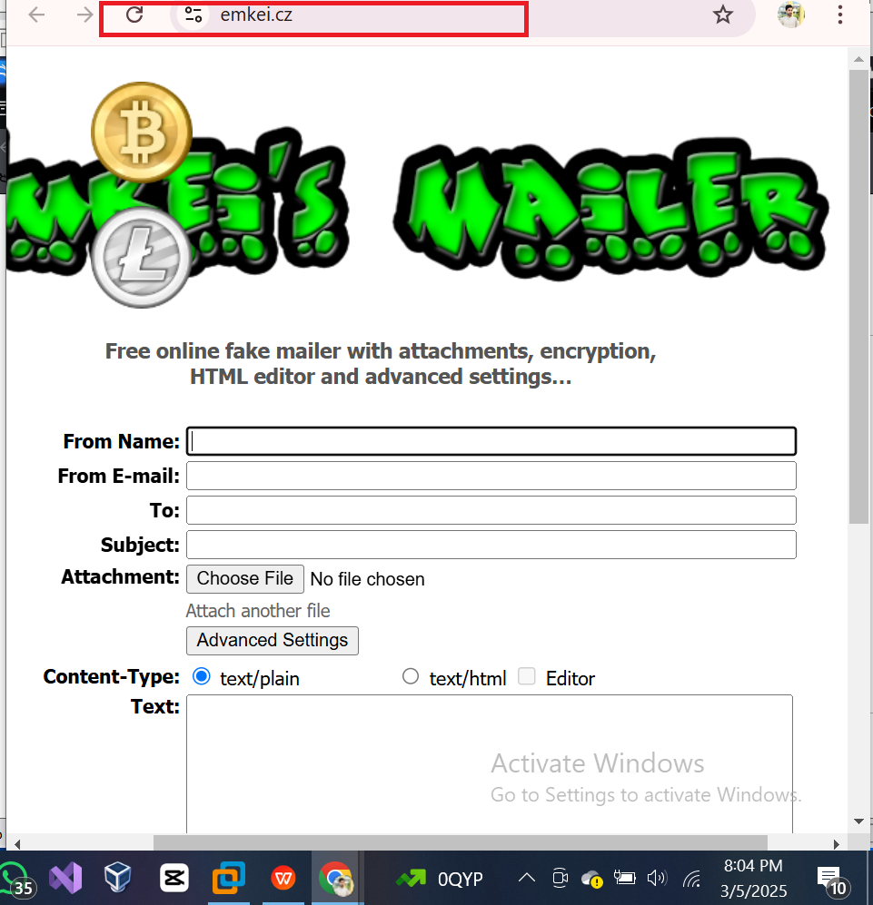

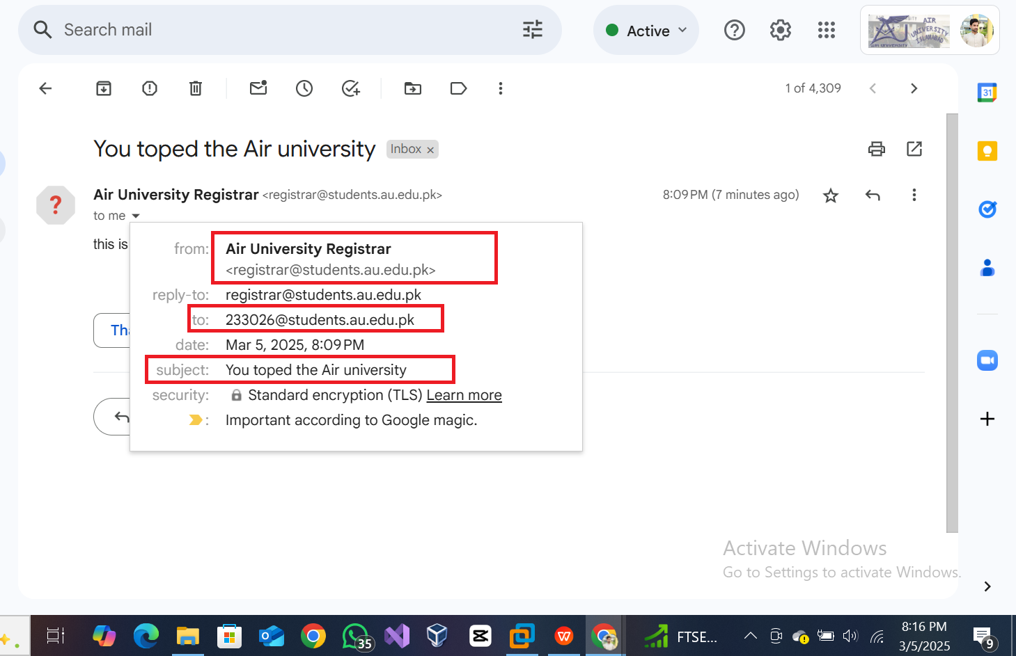

METHOD 02:

METHOD USED FOR Sending SPOOFED EMAIL

